Adityaprava Sen

CSE 2nd Year

Roll-56

Assignment on Modules(outputs)

Q1-Q5

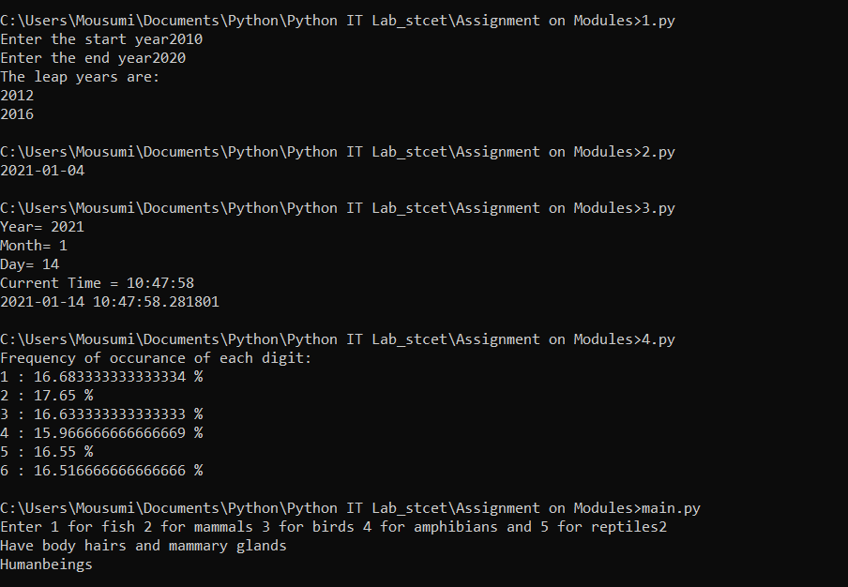

Q6.

